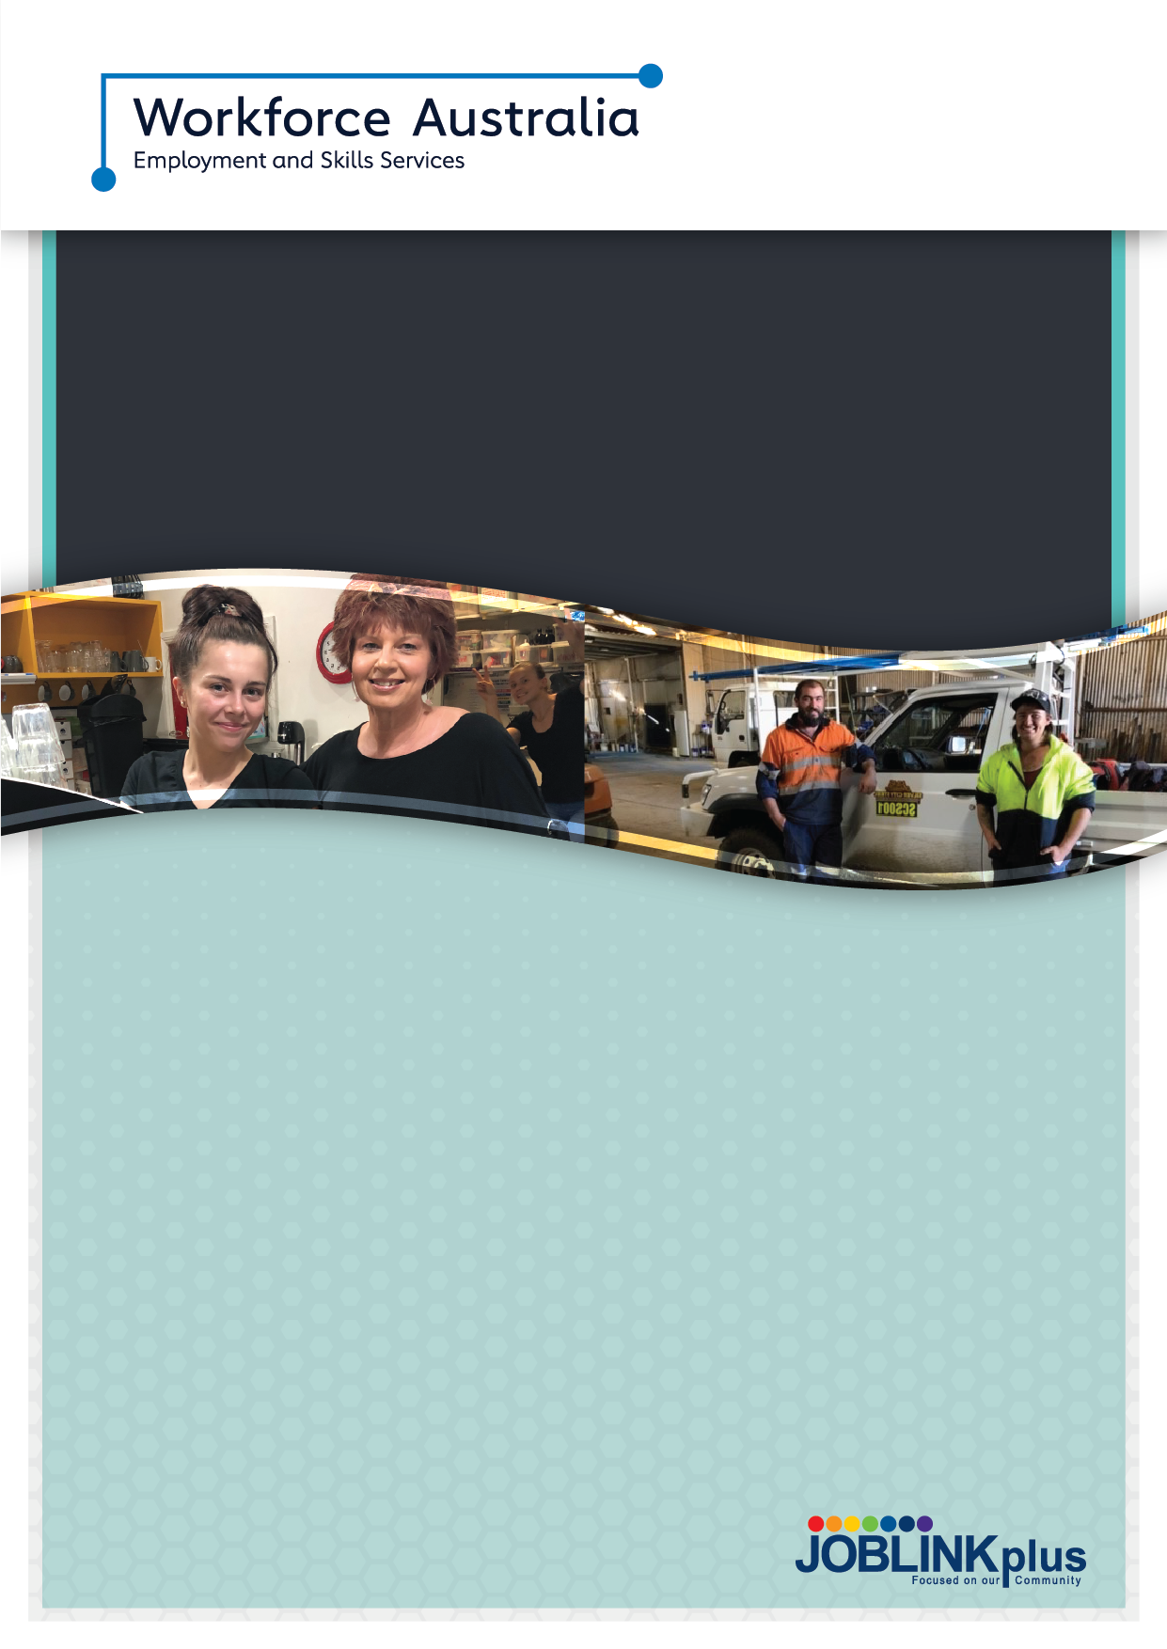

About the Transition to Work Program
Our Transition to Work program assists local regional employers to find the right staff they need at no cost. The program is specifically designed for young people from 15 to 24 years of age. Our dedicated youth specialist team provides intensive pre-employment support for young people to develop practical skills and training to get a job, connecting them with local employers, education pathways, and other opportunities.

Delivering the Transition to Work program across 40 locations across the New England North West and Far West Orana regions, our offices are easily accessible, and you are always welcome. We can also come to you.

What we offer employers
Through Transition to Work we can assist employers with our tailored services for young people. We understand that your recruitment needs are individual to your business, and we will work with you to gain a comprehensive understanding of your needs, skill requirements, workplace culture, and future plans.

What you can expect
- A dedicated team of youth specialists who are your one point of contact across the entire Joblink Plus service area
- Access to our onsite interview facilities, services and video conferencing technology
- Knowledge of a range of industries and effective recruitment for all kinds of jobs
- Targeted training for Transition to Work participants to meet the needs of identified skill gaps, both current and future, including classroom, onsite and distance learning delivery methods
- Local, regional and national level information on labor market trends, regulatory requirements and Government initiatives
- Help with Government incentives and training, ticketing or support needs to ensure the young person remains in the job long term – for example: Wage Subsidies, paid work trials, internships, and Relocation Assistance
- Pathways to apprenticeships and traineeships for Transition to Work participants through Australian Training Plus, our Registered Training Organisation or another RTO
- We’ll continue to support you and a newly employed young person for 6 months, or longer if needed through tailored Post Placement Support.

About Joblink Plus

Our purpose is to believe in and provide support to all people, connecting them to the dignity and fulfilment made possible through education and meaningful work. We work with our local communities to provide employment opportunities with sustainable outcomes.

Joblink Plus has been successfully delivering employment and community services for over thirty years and connects over 10,000 people with employment and 5,000 people with vocational training annually.

We offer ongoing support for the young people you employ

- Tailored ongoing support and mentoring to ensure that young people are retained within your organisation, including bespoke health services
- Joblink Plus Health and Wellbeing Services - one-on-one counselling with a clinician and/or group workshops to support participants with any challenges that arise
- Links and access to funding for upskilling your employees including short courses, tickets, education, traineeships, and apprenticeships through our own Registered Training Organisation (RTO) Australian Training Plus and others
- Industry-specific work ready courses designed to identify your future employees
- We believe in connections and belonging - whether it’s your sporting club or community group, Joblink Plus has strong connections in local communities and helps young people to make connections too.

Where we operate:

FAR WEST ORANA

Baradine, Binnaway, Broken Hill, Collarenebri, Coonabarabran, Coonamble, Dubbo, Gilgandra, Gulargambone, Mendooran, Mullaley, Narromine, Nyngan, Trangie, Walgett, Warren, Wellington

All opening hours can be found on our contact us page via our website.
Scan to find out more
JoblinkPlusLtd
joblink-plus
joblinkplus.com.au
1800 695 625
joblink_plus

