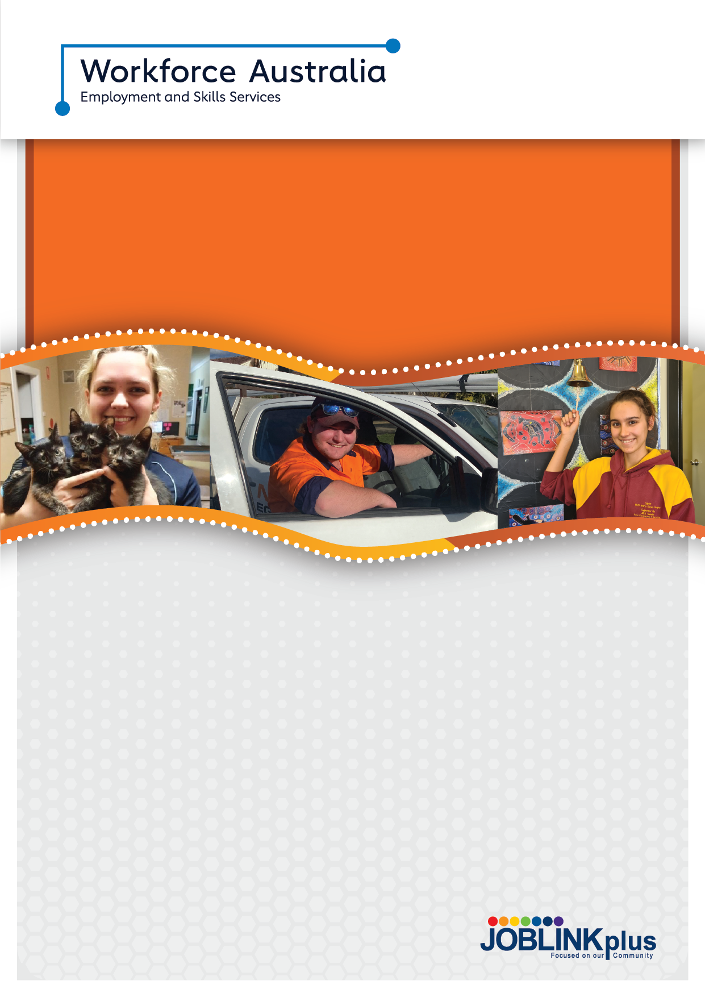

About the Transition to Work Program
Transition to Work is designed to support you to achieve your employment and education goals. Specifically designed for young people from 15 to 24 years, you’ll receive intensive, pre-employment support to gain practical skills to get a job, enrol in education or training, find local job opportunities and connect with relevant local community services.
Delivering the Transition to Work program across 40 locations across the New England North West and Far West Orana, our offices are central and easily accessible, and you are always welcome. We have a ‘drop in’ atmosphere with free Wi-Fi, mobile device charging stations, phones and computers.

Our Commitment to you
Our dedicated specialist youth team understand that your journey is as individual as you are. We’ll support you to connect with pathways to employment, education or both, overcoming any challenges each step along the way with you.
We’ll stay in touch with you at least fortnightly supporting you as you progress towards your employment and education goals and we’ll continue to support you. Once you get a job, it doesn’t stop there – we'll provide tailored post placement support to you for a minimum of six months.
We’ll treat you fairly and in a culturally sensitive way.
You can expect:
- A specialist youth consultant to individually work on a plan that supports you on your journey towards employment
- Employment opportunities within your local area or beyond
- Youth specific pre-employment programs designed with experts in the industry you want to work in so you can gain the skills you need
- Local access to short course training such as RSA, RCG and Forklift Licence to increase your employability
- A specialist youth consultant, there for you with ongoing individual support to identify and help you overcome challenges
- Group sessions offering informal learning for work readiness, job application and interview
- skills, as well as study and life skills
- Connection to gain a qualification or complete Year 12 and provide additional job coaching.

About Joblink Plus

Our purpose is to believe in and provide support to all people, connecting them to the dignity and fulfilment made possible through education and meaningful work. We work with our local communities to provide employment opportunities with sustainable outcomes.

Joblink Plus has been successfully delivering employment and community services for over thirty years and connects over 10,000 people with employment and 5,000 people with vocational training annually.

Connections and support options
- Individual Support: we’ll work together to develop an individualised plan including the services we provide and what we’ll do together on your journey to employment
- Work Ready courses: designed to identify your strengths and support you to overcome any issues preventing you from moving forward and getting work
- Drive 4 Life Driver Training: we understand how gaining your driver’s licence can increase your independence and employability. Our community-based driving school connects you with a driving instructor for lessons to help improve your confidence, get your logbook hours up, and pass your P’s test
- Traineeships and Apprenticeships: our Registered Training Organisation (RTO) Australian Training Plus can connect you to opportunities and training for traineeships and apprenticeships in a wide range of industries
- Real-life work experience opportunities and PaTH Internships: directly supporting young people with limited employment experience. We’ll connect you with employers who are willing to give you some real experience in their business
- Group support: available to you because we believe in connections and belonging. Whether it’s your sporting club or your family, Joblink Plus will connect with your people so you can connect with us. When you’re surrounded by support and people who believe in you, you’ll succeed
- Education: we can help you access education to complete Year 12 or gain a Certificate III which can open the door to more employment opportunities
- Joblink Plus Health and Wellbeing Plus: a clinician can work with you one-on-one, or in a group workshop to support you with any challenges you may have
- Community Connection: our networks ensure we can connect you with the services you might need including housing, mental health support or local youth activities and programs
- Joblink Plus Social Enterprises: we have hospitality and barbering training and apprenticeship opportunities through community businesses run by Joblink Plus.

Where we operate:

NEW ENGLAND NORTH WEST

Armidale, Ashford, Barraba, Boggabilla, Boggabri, Bundarra, Glen Innes, Gunnedah, Guyra, Inverell, Manilla, Moree, Mungindi, Narrabri, Pilliga, Quirindi, Tamworth, Tenterfield, Tingha, Uralla, Walcha, Warialda, Wee Waa

Scan to find out more
1800 695 625
joblinkplus.com.au
joblink-plus
joblink_plus
JoblinkPlusLtd

